**1. Perintah pada web browser untuk memanggil data customers**

<http://localhost/php-crud-api-main/src/api.php/records/customers>

**0utput yang dihasilkan**

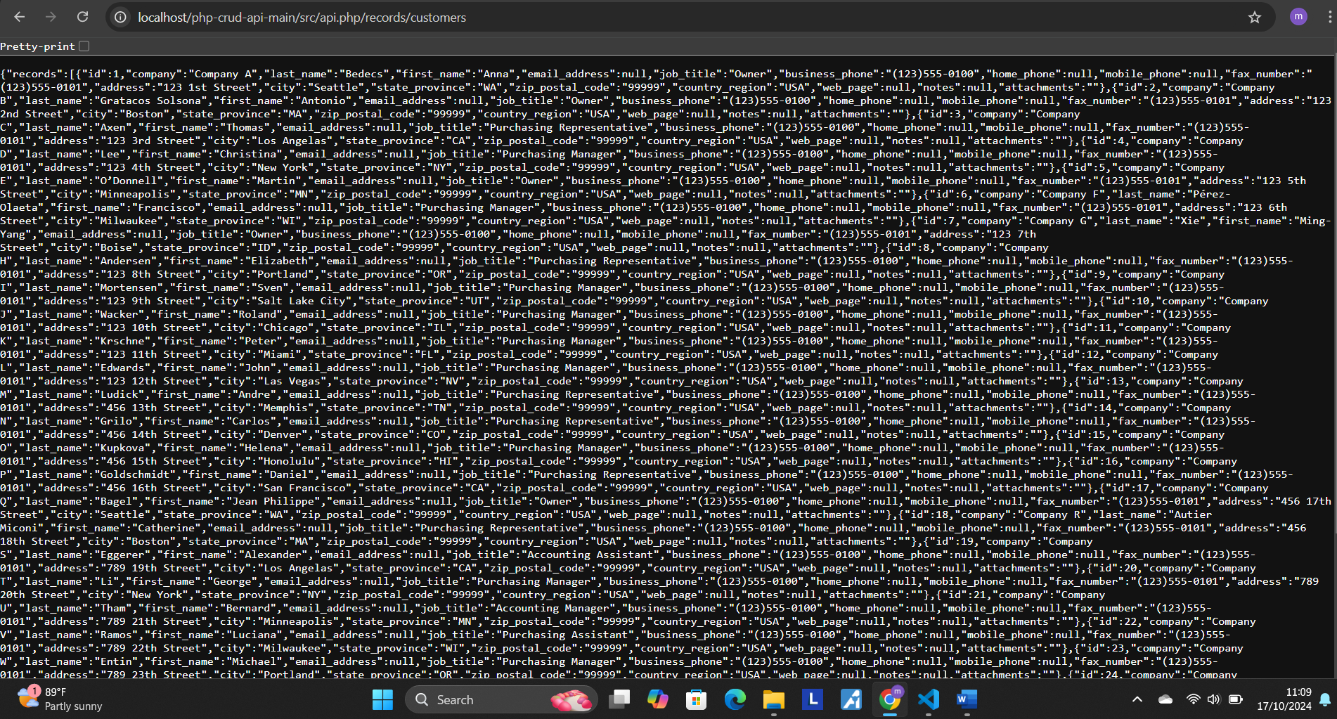

{"records":[{"id":1,"company":"Company A","last_name":"Bedecs","first_name":"Anna","email_address":null,"job_title":"Owner","business_phone":"(123)555-0100","home_phone":null,"mobile_phone":null,"fax_number":"(123)555-0101","address":"123 1st Street","city":"Seattle","state_province":"WA","zip_postal_code":"99999","country_region":"USA","web_page":null,"notes":null,"attachments":""},{"id":2,"company":"Company B","last_name":"Gratacos Solsona","first_name":"Antonio","email_address":null,"job_title":"Owner","business_phone":"(123)555-0100","home_phone":null,"mobile_phone":null,"fax_number":"(123)555-0101","address":"123 2nd Street","city":"Boston","state_province":"MA","zip_postal_code":"99999","country_region":"USA","web_page":null,"notes":null,"attachments":""},{"id":3,"company":"Company C","last_name":"Axen","first_name":"Thomas","email_address":null,"job_title":"Purchasing Representative","business_phone":"(123)555-0100","home_phone":null,"mobile_phone":null,"fax_number":"(123)555-0101","address":"123 3rd Street","city":"Los Angelas","state_province":"CA","zip_postal_code":"99999","country_region":"USA","web_page":null,"notes":null,"attachments":""},{"id":4,"company":"Company D","last_name":"Lee","first_name":"Christina","email_address":null,"job_title":"Purchasing Manager","business_phone":"(123)555-0100","home_phone":null,"mobile_phone":null,"fax_number":"(123)555-0101","address":"123 4th Street","city":"New York","state_province":"NY","zip_postal_code":"99999","country_region":"USA","web_page":null,"notes":null,"attachments":""},{"id":5,"company":"Company E","last_name":"O’Donnell","first_name":"Martin","email_address":null,"job_title":"Owner","business_phone":"(123)555-0100","home_phone":null,"mobile_phone":null,"fax_number":"(123)555-0101","address":"123 5th Street","city":"Minneapolis","state_province":"MN","zip_postal_code":"99999","country_region":"USA","web_page":null,"notes":null,"attachments":""},{"id":6,"company":"Company F","last_name":"Pérez-Olaeta","first_name":"Francisco","email_address":null,"job_title":"Purchasing Manager","business_phone":"(123)555-0100","home_phone":null,"mobile_phone":null,"fax_number":"(123)555-0101","address":"123 6th Street","city":"Milwaukee","state_province":"WI","zip_postal_code":"99999","country_region":"USA","web_page":null,"notes":null,"attachments":""},{"id":7,"company":"Company G","last_name":"Xie","first_name":"Ming-Yang","email_address":null,"job_title":"Owner","business_phone":"(123)555-0100","home_phone":null,"mobile_phone":null,"fax_number":"(123)555-0101","address":"123 7th Street","city":"Boise","state_province":"ID","zip_postal_code":"99999","country_region":"USA","web_page":null,"notes":null,"attachments":""},{"id":8,"company":"Company H","last_name":"Andersen","first_name":"Elizabeth","email_address":null,"job_title":"Purchasing Representative","business_phone":"(123)555-0100","home_phone":null,"mobile_phone":null,"fax_number":"(123)555-0101","address":"123 8th Street","city":"Portland","state_province":"OR","zip_postal_code":"99999","country_region":"USA","web_page":null,"notes":null,"attachments":""},{"id":9,"company":"Company I","last_name":"Mortensen","first_name":"Sven","email_address":null,"job_title":"Purchasing Manager","business_phone":"(123)555-0100","home_phone":null,"mobile_phone":null,"fax_number":"(123)555-0101","address":"123 9th Street","city":"Salt Lake City","state_province":"UT","zip_postal_code":"99999","country_region":"USA","web_page":null,"notes":null,"attachments":""},{"id":10,"company":"Company J","last_name":"Wacker","first_name":"Roland","email_address":null,"job_title":"Purchasing Manager","business_phone":"(123)555-0100","home_phone":null,"mobile_phone":null,"fax_number":"(123)555-0101","address":"123 10th Street","city":"Chicago","state_province":"IL","zip_postal_code":"99999","country_region":"USA","web_page":null,"notes":null,"attachments":""},{"id":11,"company":"Company K","last_name":"Krschne","first_name":"Peter","email_address":null,"job_title":"Purchasing Manager","business_phone":"(123)555-0100","home_phone":null,"mobile_phone":null,"fax_number":"(123)555-0101","address":"123 11th Street","city":"Miami","state_province":"FL","zip_postal_code":"99999","country_region":"USA","web_page":null,"notes":null,"attachments":""},{"id":12,"company":"Company L","last_name":"Edwards","first_name":"John","email_address":null,"job_title":"Purchasing Manager","business_phone":"(123)555-0100","home_phone":null,"mobile_phone":null,"fax_number":"(123)555-0101","address":"123 12th Street","city":"Las Vegas","state_province":"NV","zip_postal_code":"99999","country_region":"USA","web_page":null,"notes":null,"attachments":""},{"id":13,"company":"Company M","last_name":"Ludick","first_name":"Andre","email_address":null,"job_title":"Purchasing Representative","business_phone":"(123)555-0100","home_phone":null,"mobile_phone":null,"fax_number":"(123)555-0101","address":"456 13th Street","city":"Memphis","state_province":"TN","zip_postal_code":"99999","country_region":"USA","web_page":null,"notes":null,"attachments":""},{"id":14,"company":"Company N","last_name":"Grilo","first_name":"Carlos","email_address":null,"job_title":"Purchasing Representative","business_phone":"(123)555-0100","home_phone":null,"mobile_phone":null,"fax_number":"(123)555-0101","address":"456 14th Street","city":"Denver","state_province":"CO","zip_postal_code":"99999","country_region":"USA","web_page":null,"notes":null,"attachments":""},{"id":15,"company":"Company O","last_name":"Kupkova","first_name":"Helena","email_address":null,"job_title":"Purchasing Manager","business_phone":"(123)555-0100","home_phone":null,"mobile_phone":null,"fax_number":"(123)555-0101","address":"456 15th Street","city":"Honolulu","state_province":"HI","zip_postal_code":"99999","country_region":"USA","web_page":null,"notes":null,"attachments":""},{"id":16,"company":"Company P","last_name":"Goldschmidt","first_name":"Daniel","email_address":null,"job_title":"Purchasing Representative","business_phone":"(123)555-0100","home_phone":null,"mobile_phone":null,"fax_number":"(123)555-0101","address":"456 16th Street","city":"San Francisco","state_province":"CA","zip_postal_code":"99999","country_region":"USA","web_page":null,"notes":null,"attachments":""},{"id":17,"company":"Company Q","last_name":"Bagel","first_name":"Jean Philippe","email_address":null,"job_title":"Owner","business_phone":"(123)555-0100","home_phone":null,"mobile_phone":null,"fax_number":"(123)555-0101","address":"456 17th Street","city":"Seattle","state_province":"WA","zip_postal_code":"99999","country_region":"USA","web_page":null,"notes":null,"attachments":""},{"id":18,"company":"Company R","last_name":"Autier Miconi","first_name":"Catherine","email_address":null,"job_title":"Purchasing Representative","business_phone":"(123)555-0100","home_phone":null,"mobile_phone":null,"fax_number":"(123)555-0101","address":"456 18th Street","city":"Boston","state_province":"MA","zip_postal_code":"99999","country_region":"USA","web_page":null,"notes":null,"attachments":""},{"id":19,"company":"Company S","last_name":"Eggerer","first_name":"Alexander","email_address":null,"job_title":"Accounting Assistant","business_phone":"(123)555-0100","home_phone":null,"mobile_phone":null,"fax_number":"(123)555-0101","address":"789 19th Street","city":"Los Angelas","state_province":"CA","zip_postal_code":"99999","country_region":"USA","web_page":null,"notes":null,"attachments":""},{"id":20,"company":"Company T","last_name":"Li","first_name":"George","email_address":null,"job_title":"Purchasing Manager","business_phone":"(123)555-0100","home_phone":null,"mobile_phone":null,"fax_number":"(123)555-0101","address":"789 20th Street","city":"New York","state_province":"NY","zip_postal_code":"99999","country_region":"USA","web_page":null,"notes":null,"attachments":""},{"id":21,"company":"Company U","last_name":"Tham","first_name":"Bernard","email_address":null,"job_title":"Accounting Manager","business_phone":"(123)555-0100","home_phone":null,"mobile_phone":null,"fax_number":"(123)555-0101","address":"789 21th Street","city":"Minneapolis","state_province":"MN","zip_postal_code":"99999","country_region":"USA","web_page":null,"notes":null,"attachments":""},{"id":22,"company":"Company V","last_name":"Ramos","first_name":"Luciana","email_address":null,"job_title":"Purchasing Assistant","business_phone":"(123)555-0100","home_phone":null,"mobile_phone":null,"fax_number":"(123)555-0101","address":"789 22th Street","city":"Milwaukee","state_province":"WI","zip_postal_code":"99999","country_region":"USA","web_page":null,"notes":null,"attachments":""},{"id":23,"company":"Company W","last_name":"Entin","first_name":"Michael","email_address":null,"job_title":"Purchasing Manager","business_phone":"(123)555-0100","home_phone":null,"mobile_phone":null,"fax_number":"(123)555-0101","address":"789 23th Street","city":"Portland","state_province":"OR","zip_postal_code":"99999","country_region":"USA","web_page":null,"notes":null,"attachments":""},{"id":24,"company":"Company X","last_name":"Hasselberg","first_name":"Jonas","email_address":null,"job_title":"Owner","business_phone":"(123)555-0100","home_phone":null,"mobile_phone":null,"fax_number":"(123)555-0101","address":"789 24th Street","city":"Salt Lake City","state_province":"UT","zip_postal_code":"99999","country_region":"USA","web_page":null,"notes":null,"attachments":""},{"id":25,"company":"Company Y","last_name":"Rodman","first_name":"John","email_address":null,"job_title":"Purchasing Manager","business_phone":"(123)555-0100","home_phone":null,"mobile_phone":null,"fax_number":"(123)555-0101","address":"789 25th Street","city":"Chicago","state_province":"IL","zip_postal_code":"99999","country_region":"USA","web_page":null,"notes":null,"attachments":""},{"id":26,"company":"Company Z","last_name":"Liu","first_name":"Run","email_address":null,"job_title":"Accounting Assistant","business_phone":"(123)555-0100","home_phone":null,"mobile_phone":null,"fax_number":"(123)555-0101","address":"789 26th Street","city":"Miami","state_province":"FL","zip_postal_code":"99999","country_region":"USA","web_page":null,"notes":null,"attachments":""},{"id":27,"company":"Company AA","last_name":"Toh","first_name":"Karen","email_address":null,"job_title":"Purchasing Manager","business_phone":"(123)555-0100","home_phone":null,"mobile_phone":null,"fax_number":"(123)555-0101","address":"789 27th Street","city":"Las Vegas","state_province":"NV","zip_postal_code":"99999","country_region":"USA","web_page":null,"notes":null,"attachments":""},{"id":28,"company":"Company BB","last_name":"Raghav","first_name":"Amritansh","email_address":null,"job_title":"Purchasing Manager","business_phone":"(123)555-0100","home_phone":null,"mobile_phone":null,"fax_number":"(123)555-0101","address":"789 28th Street","city":"Memphis","state_province":"TN","zip_postal_code":"99999","country_region":"USA","web_page":null,"notes":null,"attachments":""},{"id":29,"company":"Company CC","last_name":"Lee","first_name":"Soo Jung","email_address":null,"job_title":"Purchasing Manager","business_phone":"(123)555-0100","home_phone":null,"mobile_phone":null,"fax_number":"(123)555-0101","address":"789 29th Street","city":"Denver","state_province":"CO","zip_postal_code":"99999","country_region":"USA","web_page":null,"notes":null,"attachments":""}]}

**2. Output yang muncul ketika perintah diatas menggunakan GET di postman**

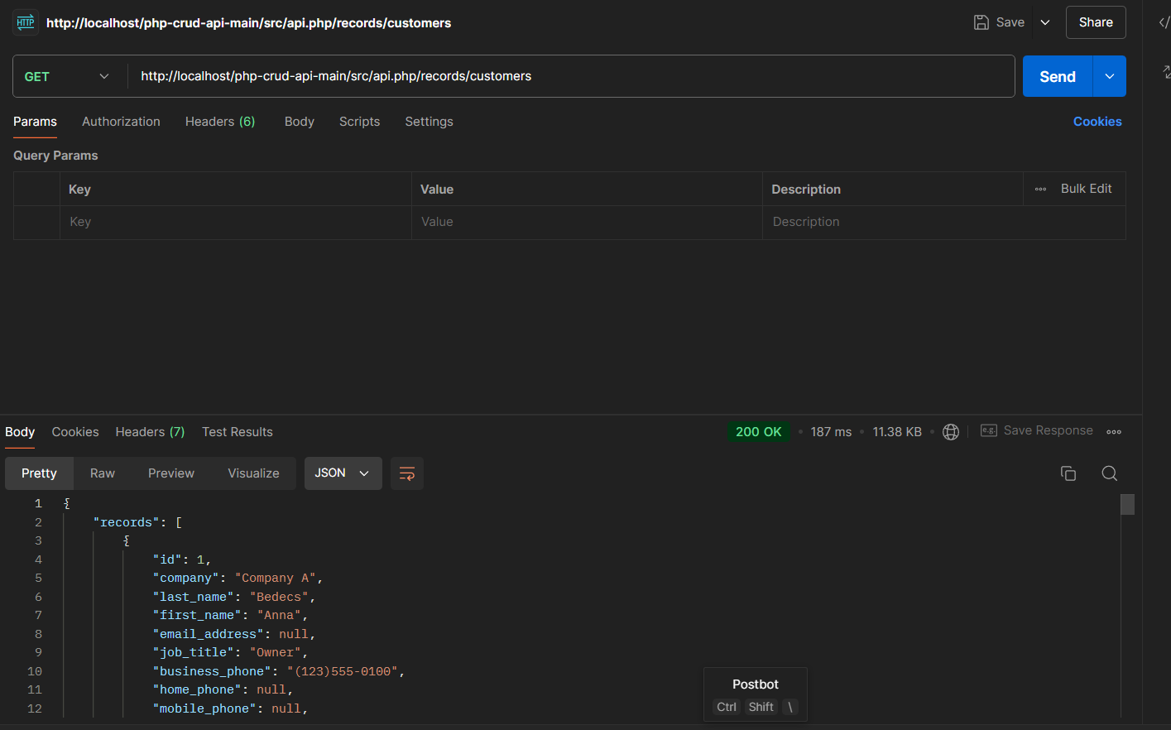

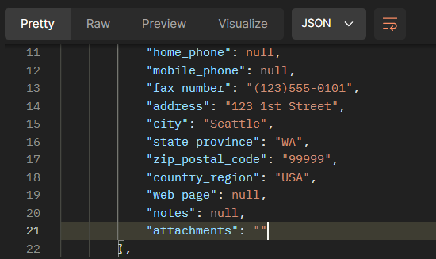

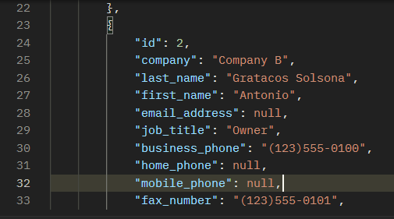

{

    "records": [

        {

            "id": 1,

            "company": "Company A",

            "last_name": "Bedecs",

            "first_name": "Anna",

            "email_address": null,

            "job_title": "Owner",

            "business_phone": "(123)555-0100",

            "home_phone": null,

            "mobile_phone": null,

            "fax_number": "(123)555-0101",

            "address": "123 1st Street",

            "city": "Seattle",

            "state_province": "WA",

            "zip_postal_code": "99999",

            "country_region": "USA",

            "web_page": null,

            "notes": null,

            "attachments": ""

        },

        {

            "id": 2,

            "company": "Company B",

            "last_name": "Gratacos Solsona",

            "first_name": "Antonio",

            "email_address": null,

            "job_title": "Owner",

            "business_phone": "(123)555-0100",

            "home_phone": null,

            "mobile_phone": null,

            "fax_number": "(123)555-0101",

            "address": "123 2nd Street",

            "city": "Boston",

            "state_province": "MA",

            "zip_postal_code": "99999",

            "country_region": "USA",

            "web_page": null,

            "notes": null,

            "attachments": ""

        },

        {

            "id": 3,

            "company": "Company C",

            "last_name": "Axen",

            "first_name": "Thomas",

            "email_address": null,

            "job_title": "Purchasing Representative",

            "business_phone": "(123)555-0100",

            "home_phone": null,

            "mobile_phone": null,

            "fax_number": "(123)555-0101",

            "address": "123 3rd Street",

            "city": "Los Angelas",

            "state_province": "CA",

            "zip_postal_code": "99999",

            "country_region": "USA",

            "web_page": null,

            "notes": null,

            "attachments": ""

        },

        {

            "id": 4,

            "company": "Company D",

            "last_name": "Lee",

            "first_name": "Christina",

            "email_address": null,

            "job_title": "Purchasing Manager",

            "business_phone": "(123)555-0100",

            "home_phone": null,

            "mobile_phone": null,

            "fax_number": "(123)555-0101",

            "address": "123 4th Street",

            "city": "New York",

            "state_province": "NY",

            "zip_postal_code": "99999",

            "country_region": "USA",

            "web_page": null,

            "notes": null,

            "attachments": ""

        },

        {

            "id": 5,

            "company": "Company E",

            "last_name": "O’Donnell",

            "first_name": "Martin",

            "email_address": null,

            "job_title": "Owner",

            "business_phone": "(123)555-0100",

            "home_phone": null,

            "mobile_phone": null,

            "fax_number": "(123)555-0101",

            "address": "123 5th Street",

            "city": "Minneapolis",

            "state_province": "MN",

            "zip_postal_code": "99999",

            "country_region": "USA",

            "web_page": null,

            "notes": null,

            "attachments": ""

        },

        {

            "id": 6,

            "company": "Company F",

            "last_name": "Pérez-Olaeta",

            "first_name": "Francisco",

            "email_address": null,

            "job_title": "Purchasing Manager",

            "business_phone": "(123)555-0100",

            "home_phone": null,

            "mobile_phone": null,

            "fax_number": "(123)555-0101",

            "address": "123 6th Street",

            "city": "Milwaukee",

            "state_province": "WI",

            "zip_postal_code": "99999",

            "country_region": "USA",

            "web_page": null,

            "notes": null,

            "attachments": ""

        },

        {

            "id": 7,

            "company": "Company G",

            "last_name": "Xie",

            "first_name": "Ming-Yang",

            "email_address": null,

            "job_title": "Owner",

            "business_phone": "(123)555-0100",

            "home_phone": null,

            "mobile_phone": null,

            "fax_number": "(123)555-0101",

            "address": "123 7th Street",

            "city": "Boise",

            "state_province": "ID",

            "zip_postal_code": "99999",

            "country_region": "USA",

            "web_page": null,

            "notes": null,

            "attachments": ""

        },

        {

            "id": 8,

            "company": "Company H",

            "last_name": "Andersen",

            "first_name": "Elizabeth",

            "email_address": null,

            "job_title": "Purchasing Representative",

            "business_phone": "(123)555-0100",

            "home_phone": null,

            "mobile_phone": null,

            "fax_number": "(123)555-0101",

            "address": "123 8th Street",

            "city": "Portland",

            "state_province": "OR",

            "zip_postal_code": "99999",

            "country_region": "USA",

            "web_page": null,

            "notes": null,

            "attachments": ""

        },

        {

            "id": 9,

            "company": "Company I",

            "last_name": "Mortensen",

            "first_name": "Sven",

            "email_address": null,

            "job_title": "Purchasing Manager",

            "business_phone": "(123)555-0100",

            "home_phone": null,

            "mobile_phone": null,

            "fax_number": "(123)555-0101",

            "address": "123 9th Street",

            "city": "Salt Lake City",

            "state_province": "UT",

            "zip_postal_code": "99999",

            "country_region": "USA",

            "web_page": null,

            "notes": null,

            "attachments": ""

        },

        {

            "id": 10,

            "company": "Company J",

            "last_name": "Wacker",

            "first_name": "Roland",

            "email_address": null,

            "job_title": "Purchasing Manager",

            "business_phone": "(123)555-0100",

            "home_phone": null,

            "mobile_phone": null,

            "fax_number": "(123)555-0101",

            "address": "123 10th Street",

            "city": "Chicago",

            "state_province": "IL",

            "zip_postal_code": "99999",

            "country_region": "USA",

            "web_page": null,

            "notes": null,

            "attachments": ""

        },

        {

            "id": 11,

            "company": "Company K",

            "last_name": "Krschne",

            "first_name": "Peter",

            "email_address": null,

            "job_title": "Purchasing Manager",

            "business_phone": "(123)555-0100",

            "home_phone": null,

            "mobile_phone": null,

            "fax_number": "(123)555-0101",

            "address": "123 11th Street",

            "city": "Miami",

            "state_province": "FL",

            "zip_postal_code": "99999",

            "country_region": "USA",

            "web_page": null,

            "notes": null,

            "attachments": ""

        },

        {

            "id": 12,

            "company": "Company L",

            "last_name": "Edwards",

            "first_name": "John",

            "email_address": null,

            "job_title": "Purchasing Manager",

            "business_phone": "(123)555-0100",

            "home_phone": null,

            "mobile_phone": null,

            "fax_number": "(123)555-0101",

            "address": "123 12th Street",

            "city": "Las Vegas",

            "state_province": "NV",

            "zip_postal_code": "99999",

            "country_region": "USA",

            "web_page": null,

            "notes": null,

            "attachments": ""

        },

        {

            "id": 13,

            "company": "Company M",

            "last_name": "Ludick",

            "first_name": "Andre",

            "email_address": null,

            "job_title": "Purchasing Representative",

            "business_phone": "(123)555-0100",

            "home_phone": null,

            "mobile_phone": null,

            "fax_number": "(123)555-0101",

            "address": "456 13th Street",

            "city": "Memphis",

            "state_province": "TN",

            "zip_postal_code": "99999",

            "country_region": "USA",

            "web_page": null,

            "notes": null,

            "attachments": ""

        },

        {

            "id": 14,

            "company": "Company N",

            "last_name": "Grilo",

            "first_name": "Carlos",

            "email_address": null,

            "job_title": "Purchasing Representative",

            "business_phone": "(123)555-0100",

            "home_phone": null,

            "mobile_phone": null,

            "fax_number": "(123)555-0101",

            "address": "456 14th Street",

            "city": "Denver",

            "state_province": "CO",

            "zip_postal_code": "99999",

            "country_region": "USA",

            "web_page": null,

            "notes": null,

            "attachments": ""

        },

        {

            "id": 15,

            "company": "Company O",

            "last_name": "Kupkova",

            "first_name": "Helena",

            "email_address": null,

            "job_title": "Purchasing Manager",

            "business_phone": "(123)555-0100",

            "home_phone": null,

            "mobile_phone": null,

            "fax_number": "(123)555-0101",

            "address": "456 15th Street",

            "city": "Honolulu",

            "state_province": "HI",

            "zip_postal_code": "99999",

            "country_region": "USA",

            "web_page": null,

            "notes": null,

            "attachments": ""

        },

        {

            "id": 16,

            "company": "Company P",

            "last_name": "Goldschmidt",

            "first_name": "Daniel",

            "email_address": null,

            "job_title": "Purchasing Representative",

            "business_phone": "(123)555-0100",

            "home_phone": null,

            "mobile_phone": null,

            "fax_number": "(123)555-0101",

            "address": "456 16th Street",

            "city": "San Francisco",

            "state_province": "CA",

            "zip_postal_code": "99999",

            "country_region": "USA",

            "web_page": null,

            "notes": null,

            "attachments": ""

        },

        {

            "id": 17,

            "company": "Company Q",

            "last_name": "Bagel",

            "first_name": "Jean Philippe",

            "email_address": null,

            "job_title": "Owner",

            "business_phone": "(123)555-0100",

            "home_phone": null,

            "mobile_phone": null,

            "fax_number": "(123)555-0101",

            "address": "456 17th Street",

            "city": "Seattle",

            "state_province": "WA",

            "zip_postal_code": "99999",

            "country_region": "USA",

            "web_page": null,

            "notes": null,

            "attachments": ""

        },

        {

            "id": 18,

            "company": "Company R",

            "last_name": "Autier Miconi",

            "first_name": "Catherine",

            "email_address": null,

            "job_title": "Purchasing Representative",

            "business_phone": "(123)555-0100",

            "home_phone": null,

            "mobile_phone": null,

            "fax_number": "(123)555-0101",

            "address": "456 18th Street",

            "city": "Boston",

            "state_province": "MA",

            "zip_postal_code": "99999",

            "country_region": "USA",

            "web_page": null,

            "notes": null,

            "attachments": ""

        },

        {

            "id": 19,

            "company": "Company S",

            "last_name": "Eggerer",

            "first_name": "Alexander",

            "email_address": null,

            "job_title": "Accounting Assistant",

            "business_phone": "(123)555-0100",

            "home_phone": null,

            "mobile_phone": null,

            "fax_number": "(123)555-0101",

            "address": "789 19th Street",

            "city": "Los Angelas",

            "state_province": "CA",

            "zip_postal_code": "99999",

            "country_region": "USA",

            "web_page": null,

            "notes": null,

            "attachments": ""

        },

        {

            "id": 20,

            "company": "Company T",

            "last_name": "Li",

            "first_name": "George",

            "email_address": null,

            "job_title": "Purchasing Manager",

            "business_phone": "(123)555-0100",

            "home_phone": null,

            "mobile_phone": null,

            "fax_number": "(123)555-0101",

            "address": "789 20th Street",

            "city": "New York",

            "state_province": "NY",

            "zip_postal_code": "99999",

            "country_region": "USA",

            "web_page": null,

            "notes": null,

            "attachments": ""

        },

        {

            "id": 21,

            "company": "Company U",

            "last_name": "Tham",

            "first_name": "Bernard",

            "email_address": null,

            "job_title": "Accounting Manager",

            "business_phone": "(123)555-0100",

            "home_phone": null,

            "mobile_phone": null,

            "fax_number": "(123)555-0101",

            "address": "789 21th Street",

            "city": "Minneapolis",

            "state_province": "MN",

            "zip_postal_code": "99999",

            "country_region": "USA",

            "web_page": null,

            "notes": null,

            "attachments": ""

        },

        {

            "id": 22,

            "company": "Company V",

            "last_name": "Ramos",

            "first_name": "Luciana",

            "email_address": null,

            "job_title": "Purchasing Assistant",

            "business_phone": "(123)555-0100",

            "home_phone": null,

            "mobile_phone": null,

            "fax_number": "(123)555-0101",

            "address": "789 22th Street",

            "city": "Milwaukee",

            "state_province": "WI",

            "zip_postal_code": "99999",

            "country_region": "USA",

            "web_page": null,

            "notes": null,

            "attachments": ""

        },

        {

            "id": 23,

            "company": "Company W",

            "last_name": "Entin",

            "first_name": "Michael",

            "email_address": null,

            "job_title": "Purchasing Manager",

            "business_phone": "(123)555-0100",

            "home_phone": null,

            "mobile_phone": null,

            "fax_number": "(123)555-0101",

            "address": "789 23th Street",

            "city": "Portland",

            "state_province": "OR",

            "zip_postal_code": "99999",

            "country_region": "USA",

            "web_page": null,

            "notes": null,

            "attachments": ""

        },

        {

            "id": 24,

            "company": "Company X",

            "last_name": "Hasselberg",

            "first_name": "Jonas",

            "email_address": null,

            "job_title": "Owner",

            "business_phone": "(123)555-0100",

            "home_phone": null,

            "mobile_phone": null,

            "fax_number": "(123)555-0101",

            "address": "789 24th Street",

            "city": "Salt Lake City",

            "state_province": "UT",

            "zip_postal_code": "99999",

            "country_region": "USA",

            "web_page": null,

            "notes": null,

            "attachments": ""

        },

        {

            "id": 25,

            "company": "Company Y",

            "last_name": "Rodman",

            "first_name": "John",

            "email_address": null,

            "job_title": "Purchasing Manager",

            "business_phone": "(123)555-0100",

            "home_phone": null,

            "mobile_phone": null,

            "fax_number": "(123)555-0101",

            "address": "789 25th Street",

            "city": "Chicago",

            "state_province": "IL",

            "zip_postal_code": "99999",

            "country_region": "USA",

            "web_page": null,

            "notes": null,

            "attachments": ""

        },

        {

            "id": 26,

            "company": "Company Z",

            "last_name": "Liu",

            "first_name": "Run",

            "email_address": null,

            "job_title": "Accounting Assistant",

            "business_phone": "(123)555-0100",

            "home_phone": null,

            "mobile_phone": null,

            "fax_number": "(123)555-0101",

            "address": "789 26th Street",

            "city": "Miami",

            "state_province": "FL",

            "zip_postal_code": "99999",

            "country_region": "USA",

            "web_page": null,

            "notes": null,

            "attachments": ""

        },

        {

            "id": 27,

            "company": "Company AA",

            "last_name": "Toh",

            "first_name": "Karen",

            "email_address": null,

            "job_title": "Purchasing Manager",

            "business_phone": "(123)555-0100",

            "home_phone": null,

            "mobile_phone": null,

            "fax_number": "(123)555-0101",

            "address": "789 27th Street",

            "city": "Las Vegas",

            "state_province": "NV",

            "zip_postal_code": "99999",

            "country_region": "USA",

            "web_page": null,

            "notes": null,

            "attachments": ""

        },

        {

            "id": 28,

            "company": "Company BB",

            "last_name": "Raghav",

            "first_name": "Amritansh",

            "email_address": null,

            "job_title": "Purchasing Manager",

            "business_phone": "(123)555-0100",

            "home_phone": null,

            "mobile_phone": null,

            "fax_number": "(123)555-0101",

            "address": "789 28th Street",

            "city": "Memphis",

            "state_province": "TN",

            "zip_postal_code": "99999",

            "country_region": "USA",

            "web_page": null,

            "notes": null,

            "attachments": ""

        },

        {

            "id": 29,

            "company": "Company CC",

            "last_name": "Lee",

            "first_name": "Soo Jung",

            "email_address": null,

            "job_title": "Purchasing Manager",

            "business_phone": "(123)555-0100",

            "home_phone": null,

            "mobile_phone": null,

            "fax_number": "(123)555-0101",

            "address": "789 29th Street",

            "city": "Denver",

            "state_province": "CO",

            "zip_postal_code": "99999",

            "country_region": "USA",

            "web_page": null,

            "notes": null,

            "attachments": ""

        }

    ]

}

**3. Program api.php dengan menggunakan Visual Studio Code**

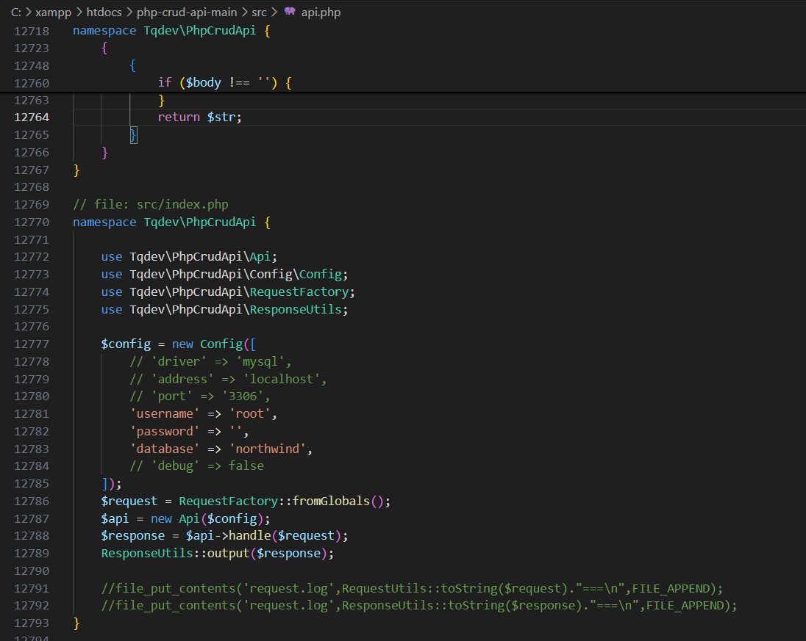

**4. Database php my admin**

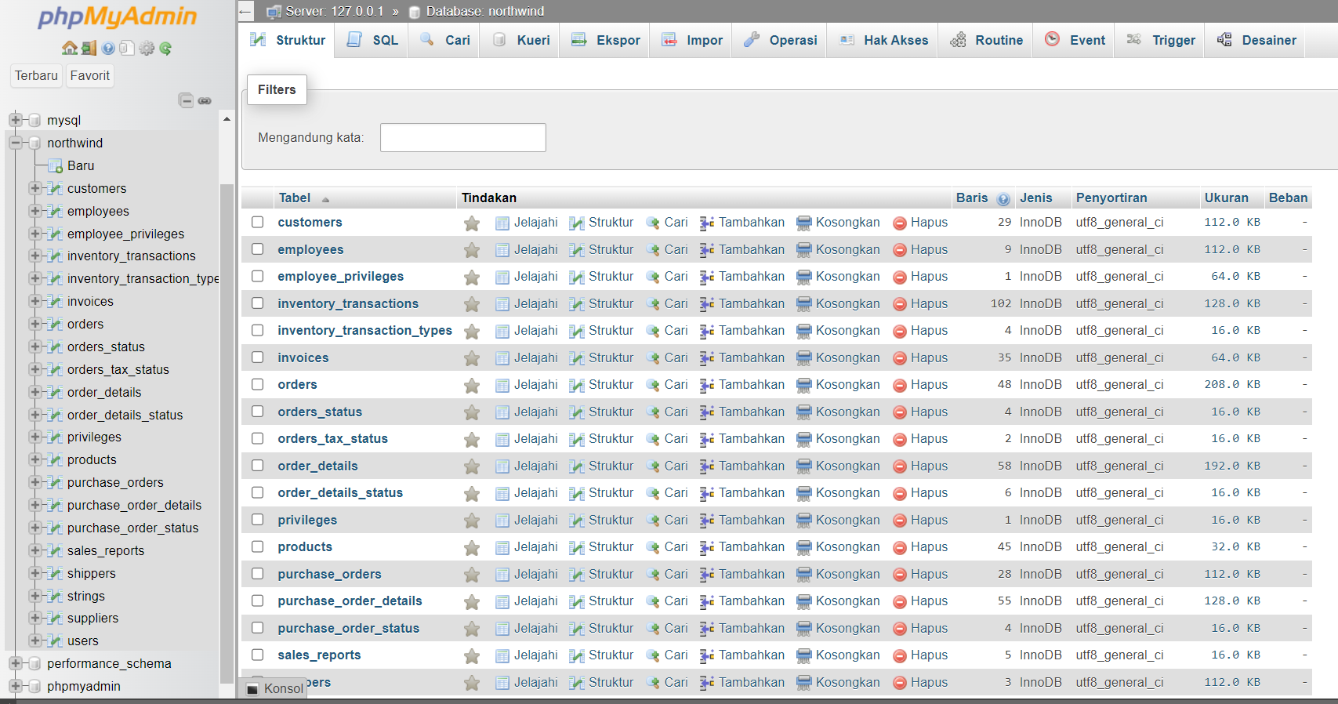

**5. Database customer nya**

